Challenge: Draw a House

**Step 1** Draw a square to make the base of the house.

* In Macintosh HD:Users:ji-sunham:Desktop:Screen Shot 2015-02-03 at 5.02.37 PM.png mode, start with these three commands:
  + pen brown
  + fd 100
  + rt 90
* You can change brown with another color.
* Press  to draw the first wall of the house.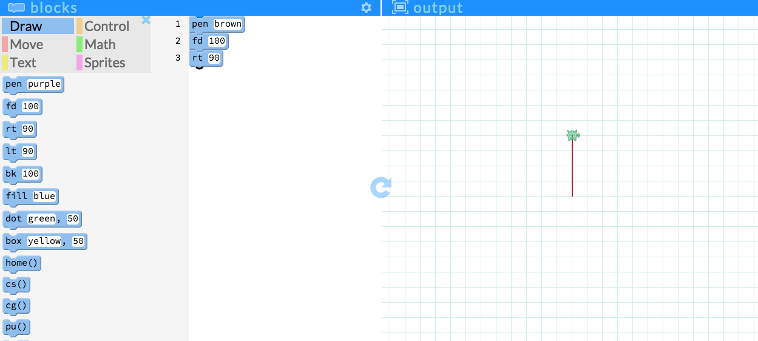
* Add fd 100 and rt 90 three more times to complete the square. Press  to check your code.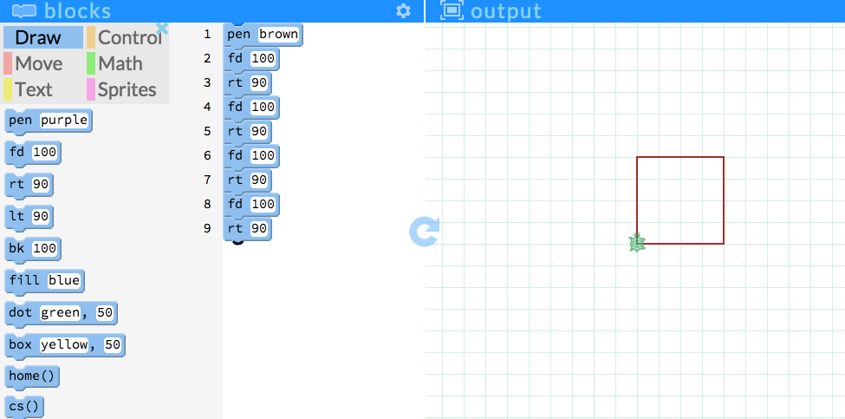

**Step 2** Draw a triangle to make the roof of the house.

* Move the turtle back to the top corner of the house by adding fd 100 again. 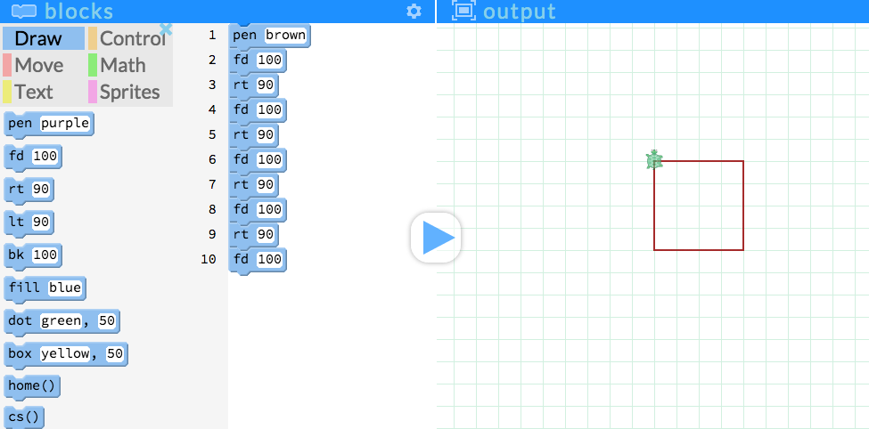
* Drag in the following commands to draw a triangle as the roof. Press  to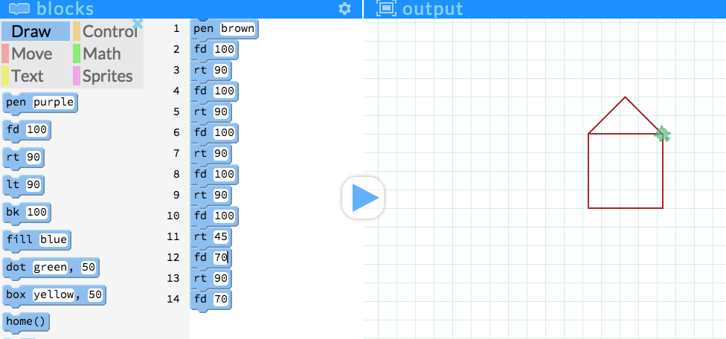

**Step 3** Color the house.

* Drag in fill red to color in the house.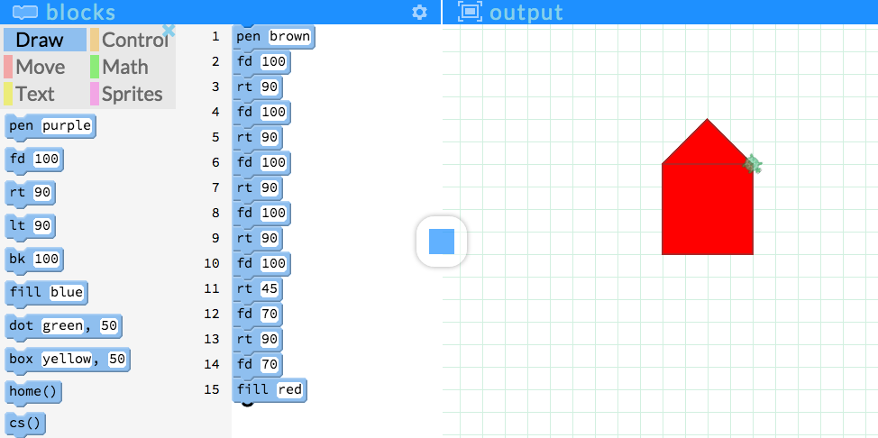
* You can change the color of the house.